Assignment Explanation

The problem
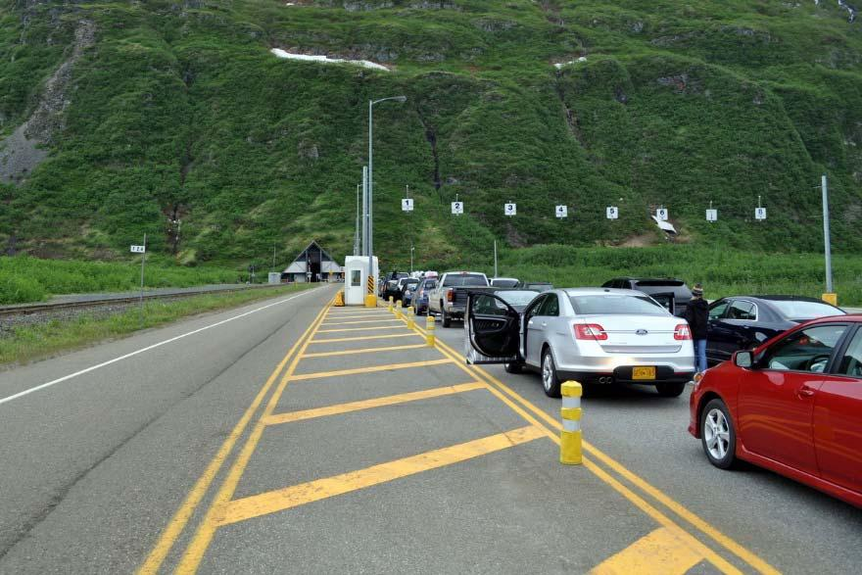

More

- A poorly ventilated tunnel

- Decided to restrict

  - Number of northbound cars

  - Number of southbound cars

  - Total number of cars

In the tunnel at any time

Your tasks

- Simulate the tunnel operation in real-time using POSIX threads (pthreads)

- Evaluate the number of cars affected by this limitation

Your program

- Main program will

  - For each input line describing a car arrival:

    - Read a time delay, a direction, and a travel time

    - Sleep for time delay

    - Create a child thread

  - Wait until all car threads have terminated

  - Print the simulation summary

The car threads

- Your car threads will

  - Print a message

  - Wait until they can enter the tunnel

  - Print a message

  - Sleep for the duration of its crossing time

  - Print a message

  - Exit the tunnel and terminate

The rules of the game

- A northbound car can enter the tunnel when there are

  - Less than maxNCars cars and

  - Less than maxNNBCars northbound inside

- A southbound car can enter the tunnel when there are

  - Less than maxNCars cars and

  - Less than maxNSBCars southbound inside

Implementation

- Quite easy with one mutex, shared counters and one condition variable

Using shared variables

- At least seven shared variables

  - Maximum number of cars in the tunnel

    - Northbound, southbound and total

  - Current numbers of cars in the tunnel

    - Northbound, southbound and total

  - Number of cars that had to wait

- Must be accessed in mutual exclusion

  - Use a mutex

Creating pthreads (I)

- Declare first a child function:

  - void *car(void *arg) {

int i;

// must cast the argument carNo = (int) arg;

…

} // car

- Thread ends with the function

Creating pthreads (II)

- Declare a thread ID

  - pthread_t tid;

- Start the thread:

  - pthread_create(&tid, NULL, car, (void *) carNo);

- Do not lose or overwrite the thread ID

  - You will need it again

Waiting for a specific thread

- Use pthread_join()

  - pthread_join(tid, NULL);

The problem

- The pthread library has no way to

  - Let you wait for an unspecified thread

  - Do the equivalent of:

    - for (i = 0; i < totalNCars; i++) wait(0);

The solution

- Must keep track of the thread id’s of all the threads of all the threads it has created:

  - pthread_t cartid[maxcars];

…

…

for (i = 0; i < totalNCars; i++) pthread_join(cartid[i], NULL);

Killing a thread

- You can use pthread_kill(…)

  - #include <signal.h>

pthread_kill(pthread_t tid, int sig);

- But

  - May terminate a thread that is inside a critical region

    - Mutex will be frozen in locked state

  - Not a problem for this assignment

Passing arguments to a thread

- pthread_create() allows a single void * argument to be passed to the new thread

pthread_create(&tid,NULL, car(void *) carNo);

- If you want to pass more than one argument, you must store them

  - In an array

  - In a structure

Pthread locks

- To create a pthread lock, use:

  - static pthread_mutex_t mylock;

// must be declared static

…

pthread_mutex_init(&mylock, NULL);

- To request the lock, use:

  - pthread_mutex_lock(&mylock);

- To release the lock, use:

  - pthread_mutex_unlock(&mylock);

Pthread condition variables (I)

- The easiest way to create a condition variable is:

- pthread_cond_t clear =

PTHREAD_COND_INITIALIZER;

Pthread condition variables (II)

- To wait on a condition:

  - pthread_mutex_lock(&mymutex); while (…)

pthread_cond_wait(&clear,

&mymutex);

…

pthread_mutex_unlock(&mymutex);

A reminder

- Signals that are not caught by a waiting process are lost
  - Before setting up a pthread_cond_wait(), you must be sure that the resource you are waiting for is actually unavailable and the thread that holds it will do a pthread_cond_signal() when it releases it.

  - A thread holding a resource or changing the status of the tunnel should always send a pthread_cond_signal()

Pthread condition variables (III)

- To signal a condition:

  - pthread_mutex_lock(&mymutex);

…

pthread_cond_signal(&clear); pthread_mutex_unlock(&mymutex);

- Critical section must use the same mutex as the one used around the corresponding pthread_cond_wait( )

Pthread condition variables (IV)

- To wake up everyone:

  - pthread_mutex_lock(&mymutex);

…

pthread_cond_broadcast(&clear); pthread_mutex_unlock(&mymutex);

- Critical section must use the same mutex as the one used around the corresponding pthread_cond_wait( )
The car threads revisited (I)

- Decided to have different thread functions for northbound and southbound cars

  - Even though they are nearly identical

  - Makes code much simpler

  - Should not brag about it

- They share

    - Single car_lock mutex

    - Single wake_up condition variable

The car threads revisited (II)

- Your car threads will

  - Request car_lock mutex

  - Print a message

  - Check tunnel admission conditions

  - If needed, wait for a signal from a car leaving

  - Update counters

  - Print a message

  - Release car_lock mutex

The car threads revisited (III)

- …

  - Sleep for the duration of their crossing time

  - Request traffic_lock mutex

  - Update counters

  - Print a message

  - Broadcast a change

  - Release traffic_lock mutex

  - Terminate

The condition variable

- A car may have to wait for the departure of

  - A car going in its direction

  - A car going in the opposite direction

- Use the same condition variable for all cars

- Receiving a signal does not guarantee that the car will be able to enter the tunnel
  - Must use a while

while (cannot_enter) {

pthread_cond_wait(&wake_up, &car_lock);

A last word

- This assignment is about learning to use pthread calls and condition variables

- Two mild challenges are

  - Learning to pass multiple arguments to pthreads

  - Accessing condition variables from within the correct critical sections

- Your code should be less than 200 lines

